

COIT 20257: Distributed Systems: Principles and Development

Term 2 2021

Assignment 1: Remote Invocation Framework

**Lecturer:** Dr. Wei Li

**Prepared by:**

Iftekhar Alam [12171117]

**Program use and test instruction:**

Steps to compile and run the program using Netbeans IDE-

1. Extract files from the Assignment1.zip folder. There are two folders in it; ComputeClient and ComputeServer.
2. Open netbeans IDE, go to open project, navigate to where the Assignment1 zip folder has been extracted, select ComputeServer and open.
3. Open ComputeClient tha same way as the ComputeServer project. They should be opened as separate projects.
4. Right click on each project and click on “clean and build”. The projects should be ready to run at this point.

To use the program:

This is what the project folder looks like in the beginning.

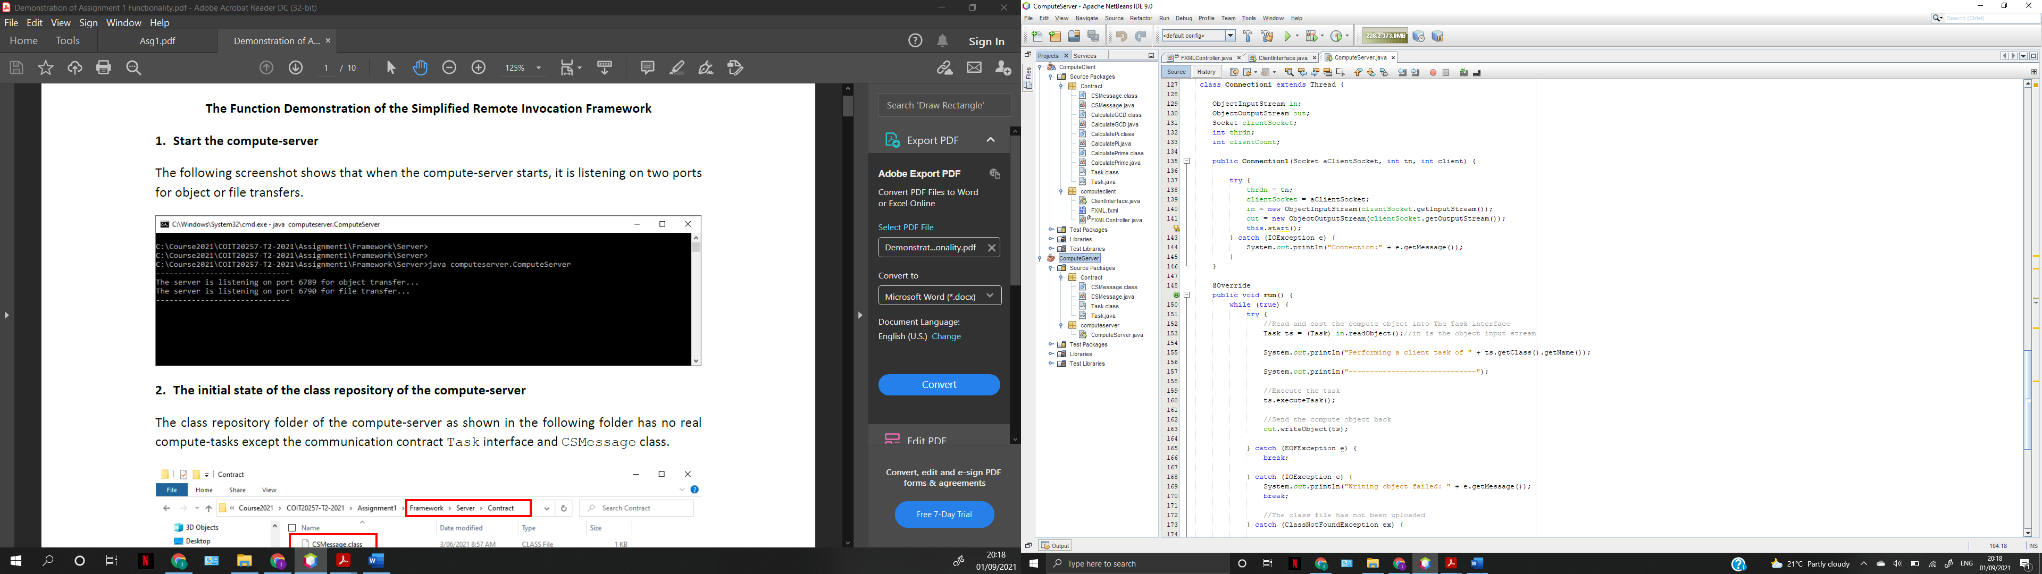

Right click on ComputeServer first, and then click on run file. The server should be ready for connection now.

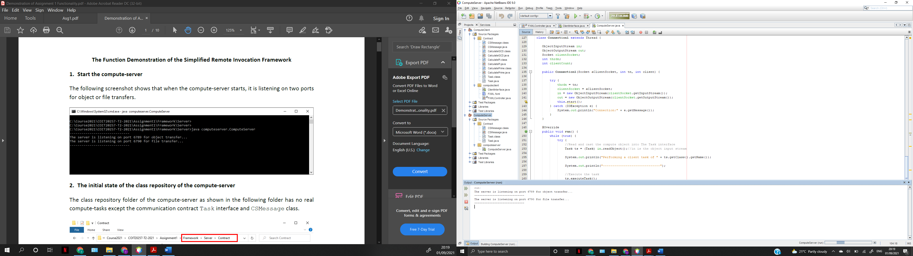

Then right click on ComputeClient, and then run. The GUI will appear. There would be no TCP connection established as of yet. The task list menu, upload, and calculate buttons are disabled at this point since there are no connections present.

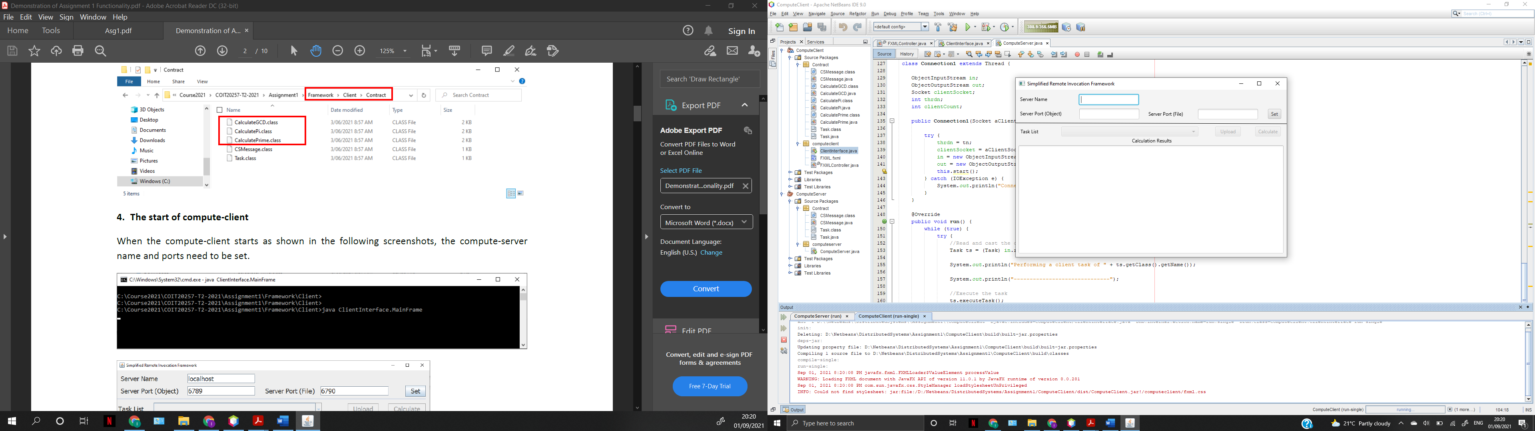

Type in the Server name, server port for object, and server port for file as shown below. Make sure the ports and the name are as shown below. This is because the server is listening on those ports.

Once you click on set and a connection is established, the task list and the other buttons are enabled.

To test the Calculate Pi task. Select the task and click on upload to copy the task class file to the server’s repository.

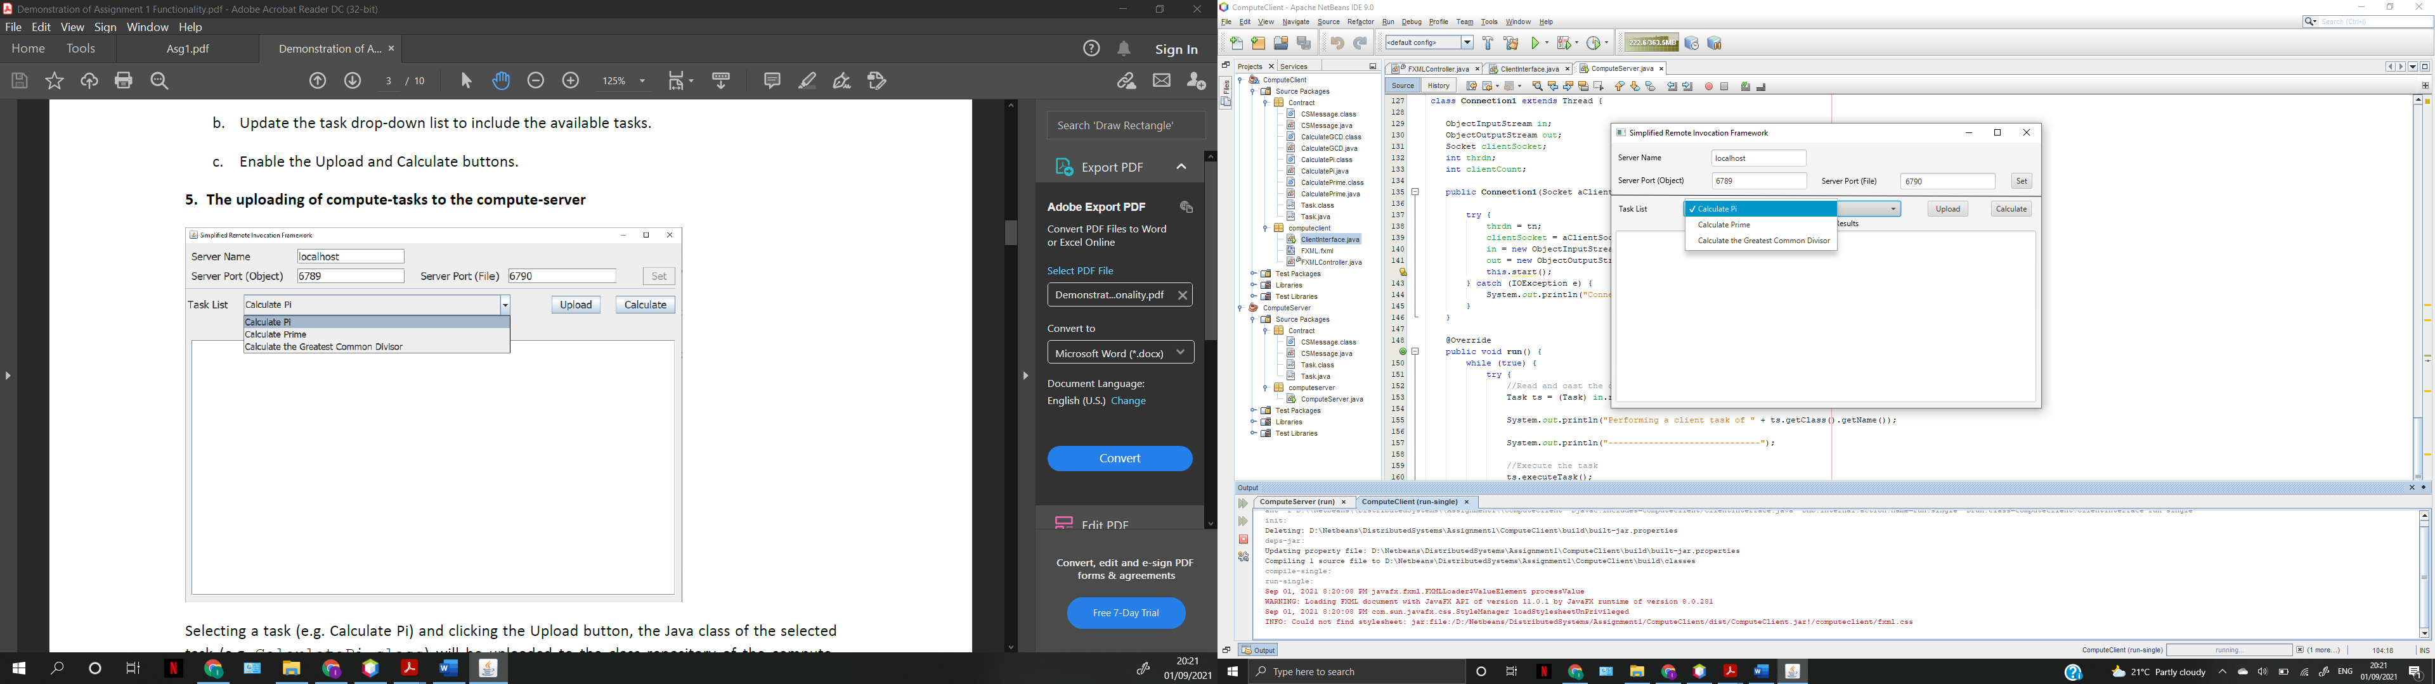

The client uploads the class file and displays the message shown below.

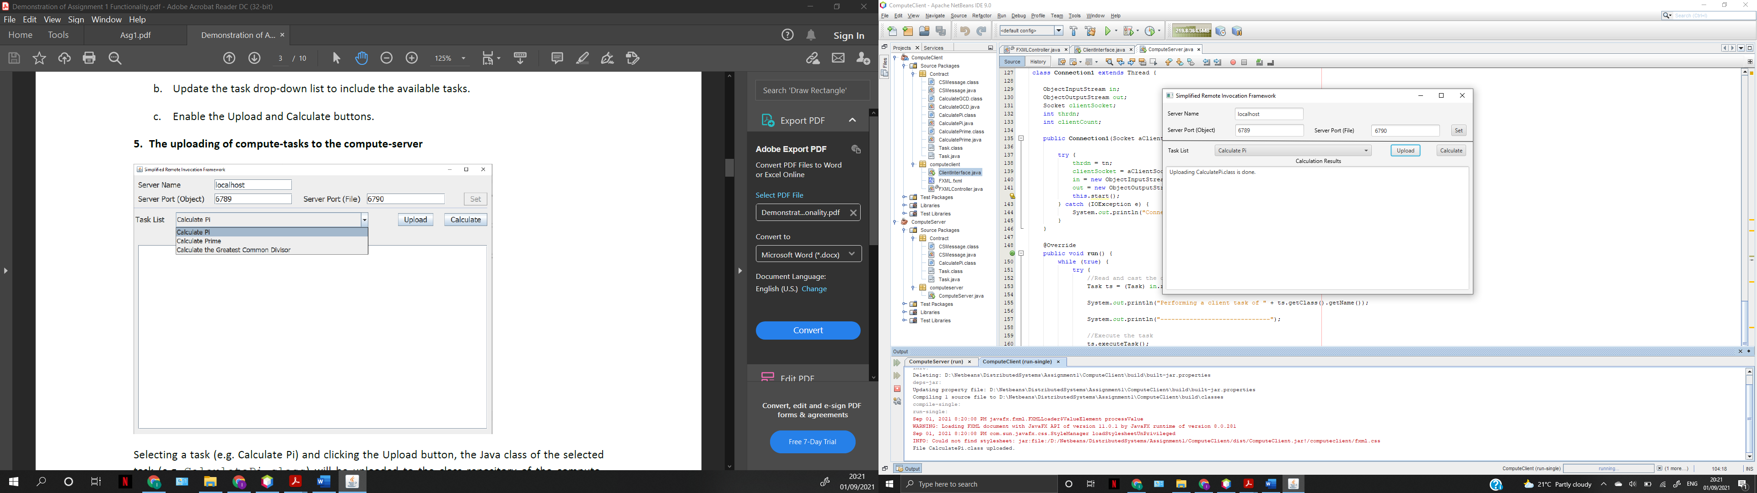

Click on the calculate button and enter the decimal places you want in the dialog box that pops up as shown below.

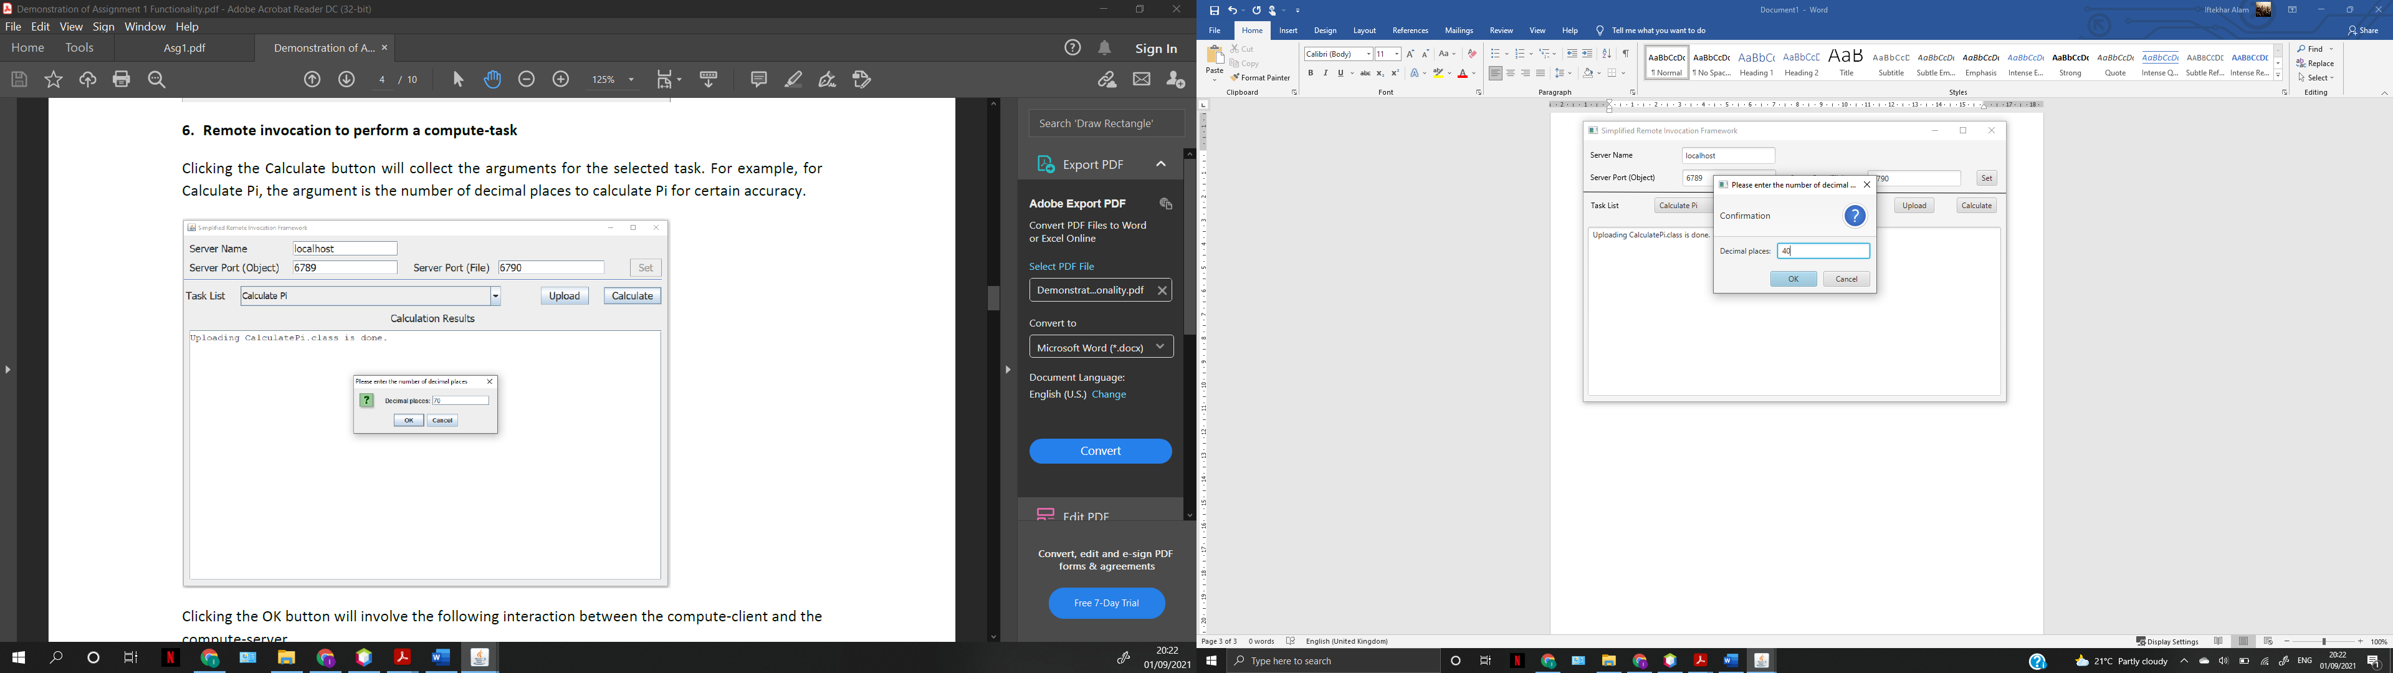

Once clicked on OK, the result is displayed in the text area as shown below.

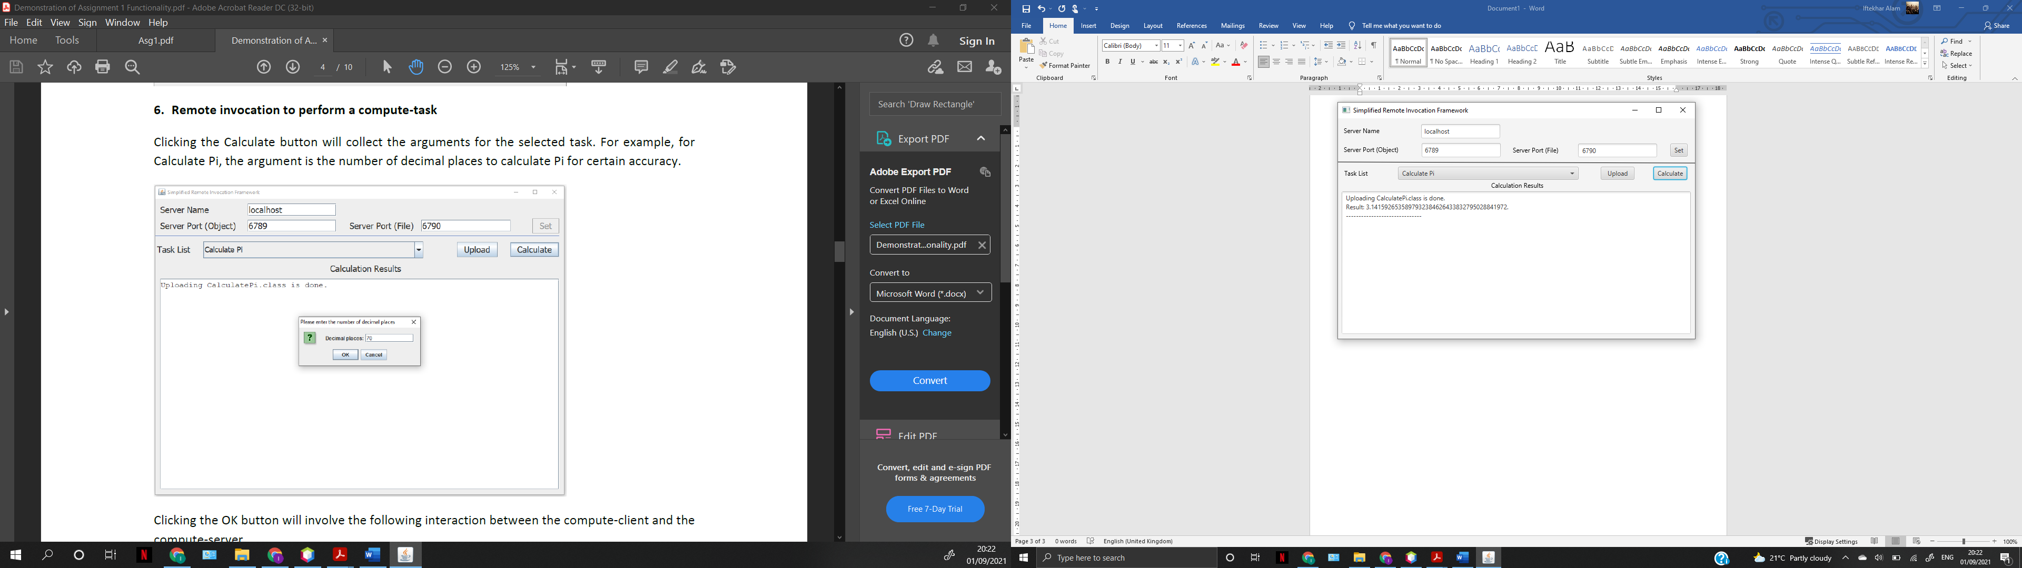

To test the Caculate Prime task, simply select it from the menu and click on upload. Once the client displays that the file is uploaded, click on calculate. A dialog box will pop where you have to enter the integer.

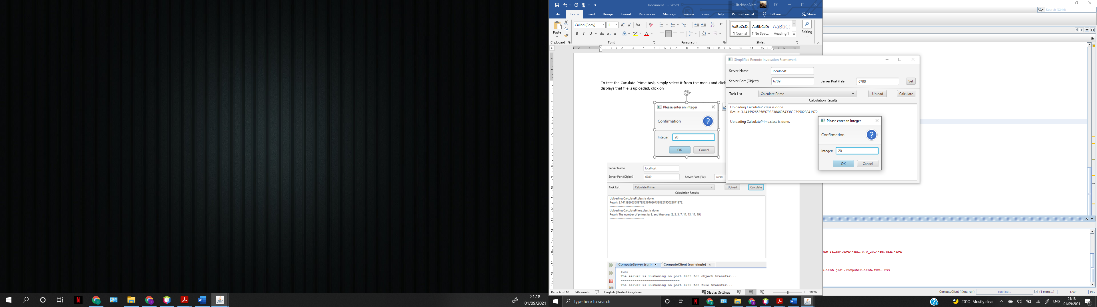

Once clicked on OK, the result is displayed below.

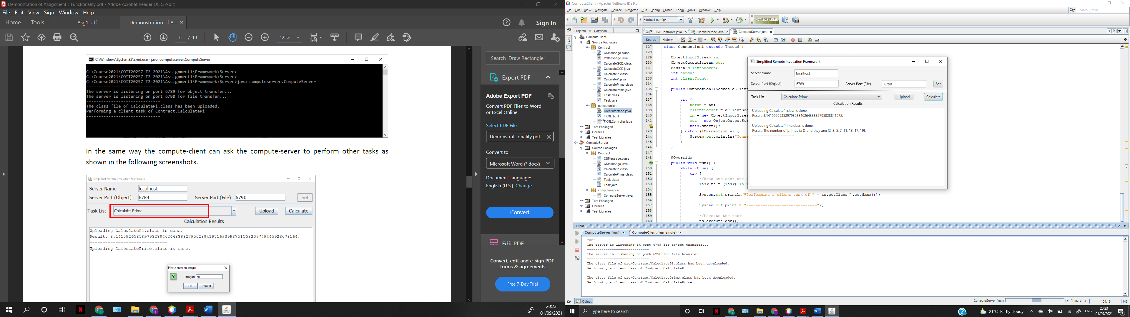

This is what the server console looks like at this point.

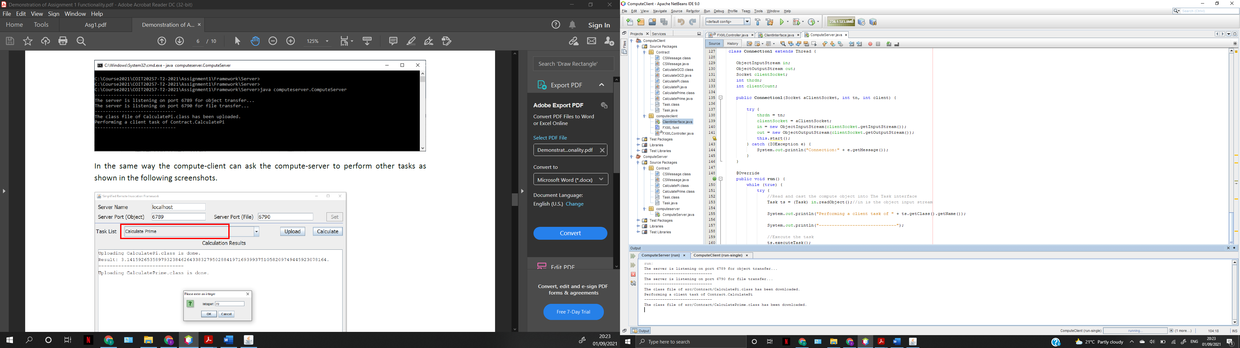

To test the Calculate GCD and the ‘not uploading task’ exception. Select the calculateGCD from the task list and click on calculate instead of uploading class file first.

Then enter the 2 integers as prompted below.

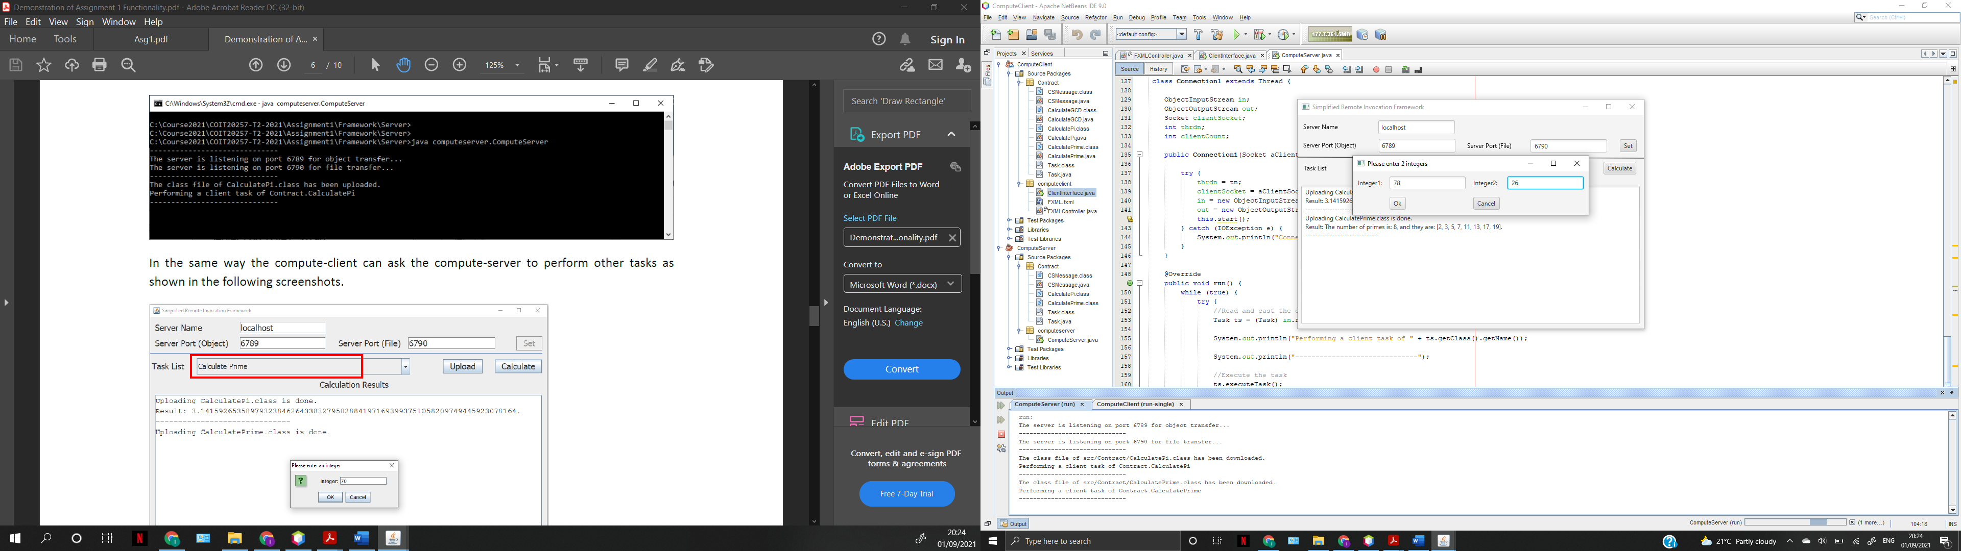

Once you click ok, the exception is handled by displaying an instruction to upload the compute-task class file first as shown below.

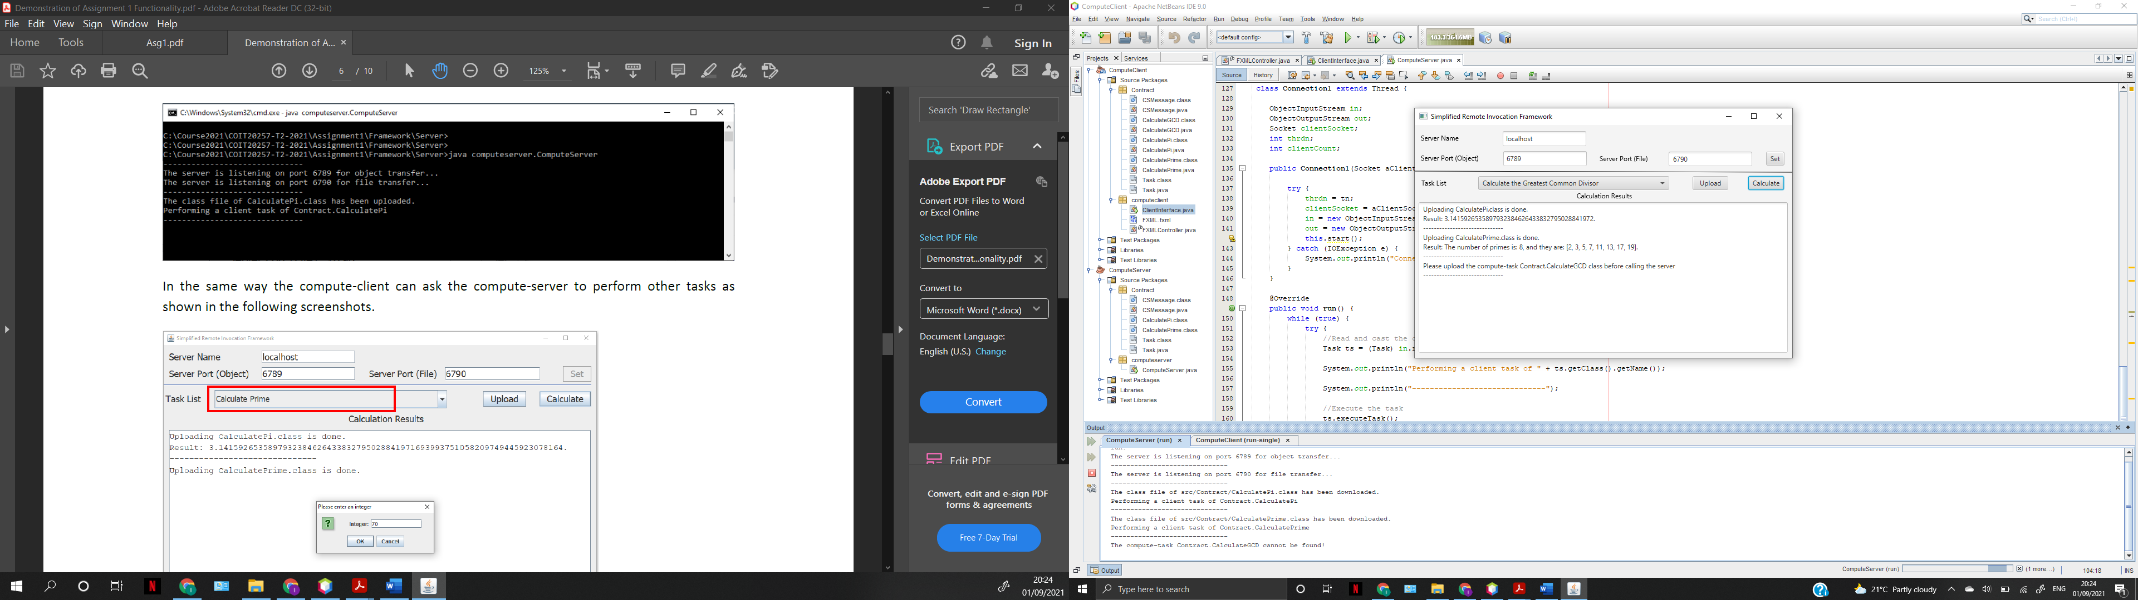

After you click on upload, the client then uploads the file to the server’s respository.

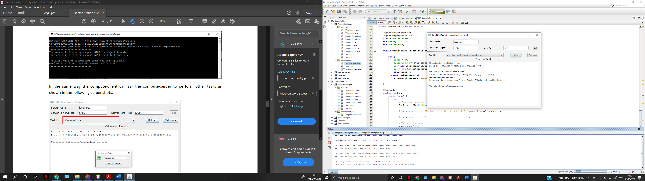

Server’s console output at this point:



To test the calculate GCD task, select the task then upload the class file. Click on calculate and enter the integers as prompted.

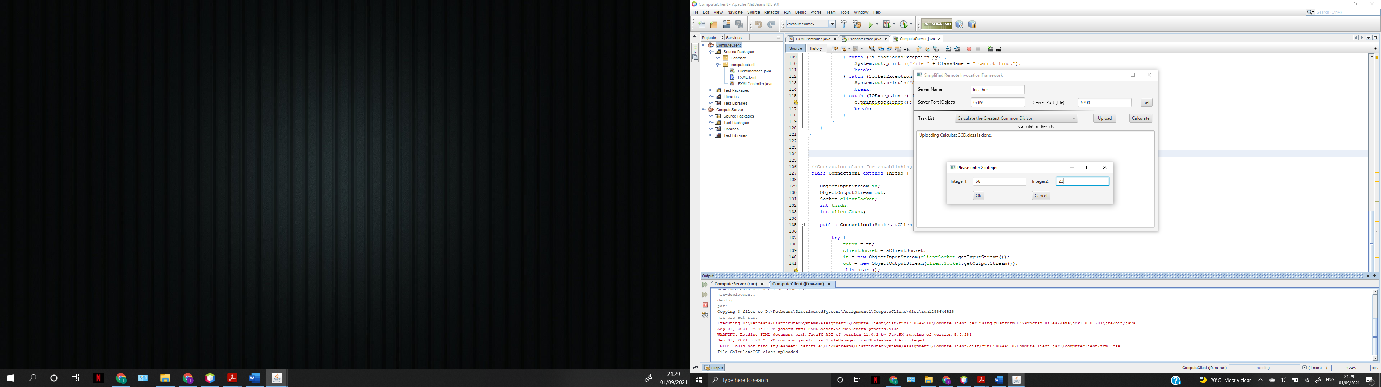

The server then computes the task and sends the task back to the client with the computation result. The result is then displayed to the user.

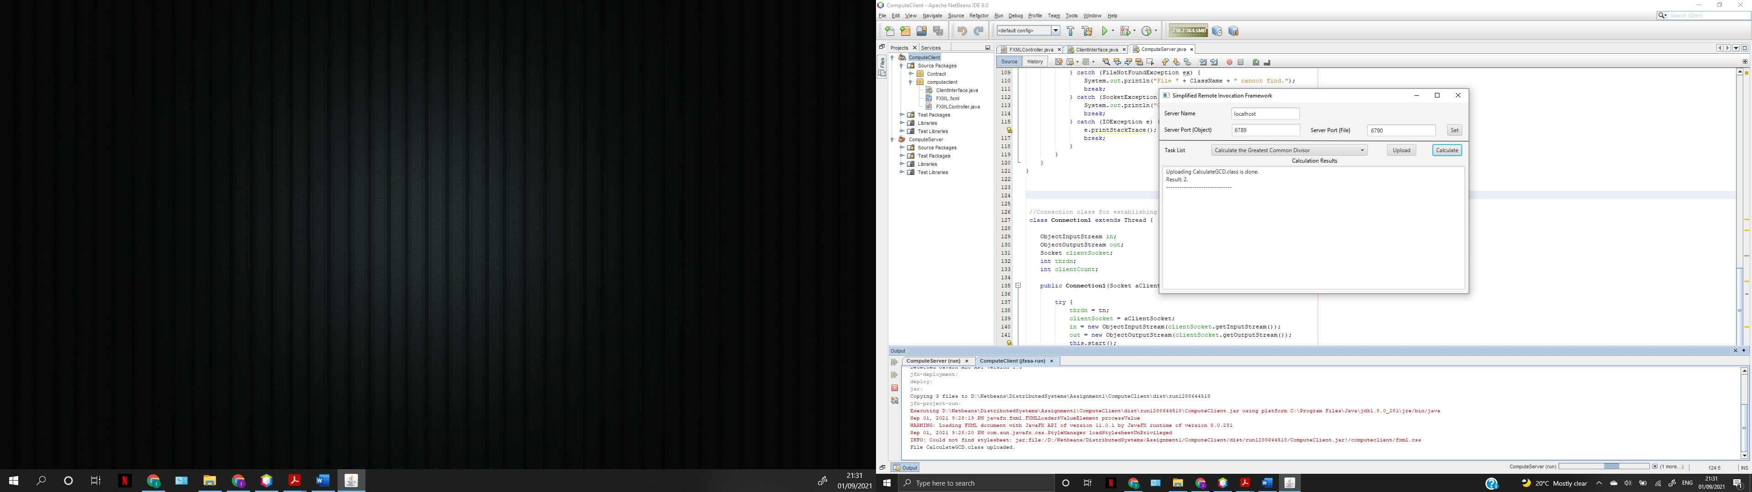

The client’s console output at this point:

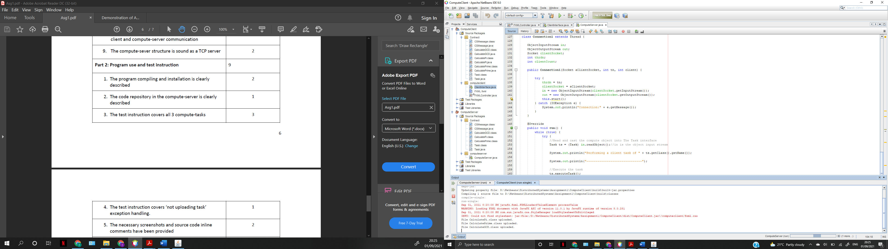

The server’s console output at this point:

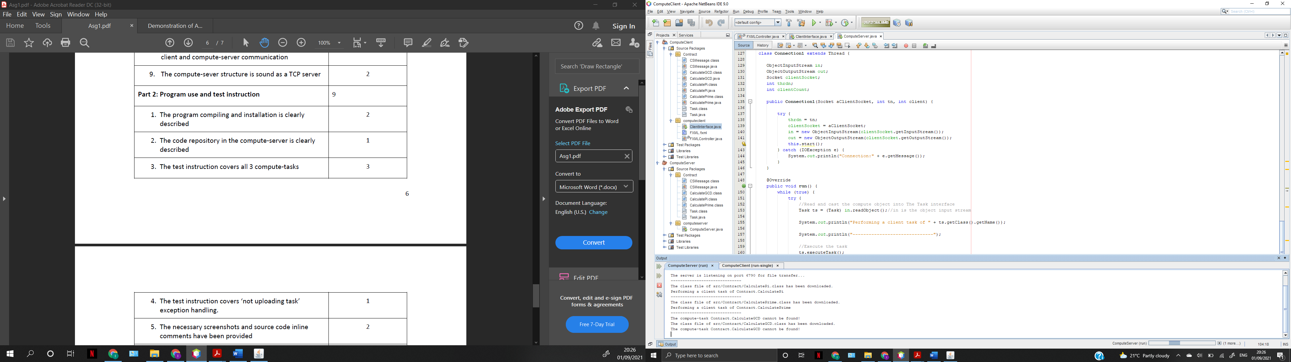

Below screenshot shows the repository of the ComputeServer now after the program has been run and all computation tasks have been tested.

The server’s repository is the “Contract” package where all the compute-tasks classes are saved. As the compute-client uploads the computation classes, these uploads are saved in this repository of the server. The server then refers to the classes in order to downcast the incoming task objects from the client. It then computes the tasks using these classes.

